Daniel Schwartz  
Social Network Analysis 09-10-2022

Assignment 7

1. 1. Density: 0.037
   2. Rows: 62
   3. Cols: 40
   4. Components:

1. 1. Composer projection

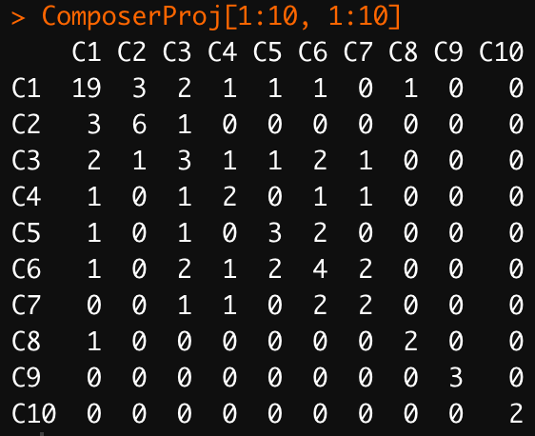

* 1. C17 and C31 worked with the same producer most often, a total of 5 times



Degree:

Composers C1 and C17 are most central

Producers P33 and P53 are most central

Betweenness:



Composers C1 and C25 are most central

Producers P11 and P44 are most central



Producers are green

Consumers are blue



Subgroup density table:

Bipartite network

